Poonam Karki
Ph.D. Student | Soil Microbial Ecology & Nitrogen Cycling
Saint Louis University
Exploring the microbial processes that regulate soil health, nutrient cycling, and ecosystem function
My research bridges soil science, microbial ecology, and sustainable agriculture to understand how microorganisms regulate nitrogen transformations in agricultural ecosystems.
[View My Research] [View CV]

Research Focus
Connecting Soil Health with Microbial Function
My research interests center on understanding how soil microbial communities influence nitrogen and carbon cycling, soil fertility, greenhouse gas emissions, and overall soil health.
I am particularly interested in connecting traditional soil health measurements with molecular and functional approaches to better understand not only how soils respond to agricultural management, but why those responses occur at the microbial level.
Soil Microbial Ecology
Understanding the structure, function, and responses of soil microbial communities to agricultural management and environmental change.
Nitrogen & Carbon Cycling
Investigating microbial processes involved in nutrient transformations and their connections to soil fertility, nutrient availability, and greenhouse gas emissions.
Soil Health & Sustainable Agriculture
Connecting microbial and biogeochemical processes with practical soil health indicators and management strategies for resilient agricultural systems.

Current Position
Ph.D. Student & Graduate Teaching Assistant
Department of Biology | Saint Louis University
Huang Microbial Ecology Lab | 2026–Present
I am currently pursuing my Ph.D. in Biology at Saint Louis University in Dr. Laibin Huang's Microbial Ecology Lab. (Dr. Huang Microbial Ecology Lab | Nitrogen)
My doctoral training builds upon my previous research in soil health and sustainable agriculture by moving toward a more mechanistic understanding of the microorganisms responsible for nutrient transformations in soil.
My research interests include soil microbial ecology, microbial nitrogen cycling, carbon cycling, soil health, and greenhouse gas emissions. I am developing experience with molecular and computational approaches that can be integrated with soil biogeochemical measurements to investigate microbial community structure and function.
As a Graduate Teaching Assistant, I teach BIOL 1245 – Principles of Biology I Laboratory, where I guide undergraduate students through laboratory activities, reinforce fundamental biological concepts, assist with experimental techniques and data interpretation, and promote safe laboratory practices.

Current Research Direction
Microbial Nitrogen Cycling & Soil Health
Nitrogen availability in agricultural soils is controlled by a complex network of microbial processes. Understanding these processes is essential for improving nutrient-use efficiency, maintaining soil fertility, and reducing environmental nitrogen losses.
My current research interests focus on understanding how agricultural management influences nitrogen-cycling microorganisms, functional genes, nutrient transformations, and greenhouse gas emissions.
I am particularly interested in microbial processes such as:
Nitrogen Fixation • Mineralization • Nitrification • Denitrification • DNRA • Other Microbial Nitrogen Transformations
My doctoral training integrates approaches such as soil biogeochemical measurements, DNA extraction, quantitative PCR (qPCR), amplicon sequencing, greenhouse gas measurements, bioinformatics, and omics-based approaches.
My long-term goal is to connect changes in microbial communities and functional pathways with measurable changes in soil nitrogen availability, soil health, and ecosystem function.

My Research Journey
From Soil Health Indicators to Microbial Mechanisms
My research journey began with a fundamental question:
How can agricultural management improve soil health?
During my master's research and subsequent work as a Soil Health Research Specialist at Lincoln University of Missouri, I investigated this question using biological and biochemical indicators of soil health.
My work included measurements of soil organic carbon, total nitrogen, mineralizable carbon, potentially mineralizable nitrogen, permanganate oxidizable carbon (POXC), extracellular enzyme activities, soil protein, and microbial community characteristics.
These indicators helped reveal how agricultural management influences biologically active pools of carbon and nitrogen.
However, they also led me to a deeper question:
Which microorganisms and microbial processes are responsible for the changes we observe in soil?
My Ph.D. training at Saint Louis University represents the next stage of that journey.
I am now expanding from measuring soil health responses toward understanding the microbial mechanisms underlying carbon and nitrogen cycling.
By integrating soil health measurements with molecular microbial ecology and bioinformatics, I hope to better connect:
Agricultural Management → Microbial Communities → Functional Processes → Nutrient Cycling → Soil Health
Ultimately, my goal is to bridge fundamental microbial ecology with applied soil science to contribute to more productive, resilient, and environmentally sustainable agricultural systems.

Previous Research Experience
Soil Health Research Specialist
Lincoln University of Missouri | 2024–2026
Before beginning my Ph.D. at Saint Louis University, I worked as a Soil Health Research Specialist in Dr. Tunsisa Hurisso's Soil Health Research Lab at Lincoln University of Missouri.
My research focused on soil health, microbial ecology, carbon and nitrogen cycling, cover crops, organic agriculture, and climate-resilient production systems.
I contributed to USDA-funded research investigating how conservation and agricultural management practices influence soil biological functioning, nutrient cycling, weed management, crop production, and agricultural resilience.

Previous Research Projects
Organic Transition Project
USDA-NIFA Funded Research
This research examined the integration of living cover crops into traffic pathways between vegetable production beds during transition to certified organic management.
The project investigated whether cover crops could improve soil health while providing additional benefits such as weed suppression and increased biological activity in intensively managed organic vegetable systems.
My research examined changes in soil carbon and nitrogen pools, microbial activity, extracellular enzyme activity, microbial community composition, cover crop biomass, and weed seedbank dynamics.
This project helped establish the foundation for my interest in understanding how agricultural management influences soil microbial processes.

Solar Corridor Cropping System
USDA Conservation Innovation Grant
The Solar Corridor Cropping System project evaluated an alternative cropping and winter-feeding strategy designed to improve livestock production while supporting soil health and agricultural resilience.
The system integrates grain and forage crops to provide livestock grazing opportunities while reducing dependence on harvested feed and other production inputs.
My role focused primarily on evaluating how the production system influenced soil health and carbon and nitrogen cycling.

My Role in the Research
Across these projects, I conducted or contributed to measurements and analyses including:
Total Carbon & Nitrogen
Assessment of soil carbon and nitrogen pools.
Permanganate Oxidizable Carbon (POXC)
Measurement of a biologically responsive soil carbon fraction.
Mineralizable Carbon
Assessment of microbial decomposition and soil biological activity.
Potentially Mineralizable Nitrogen (PMN)
Evaluation of the soil's biologically available nitrogen supply.
Extracellular Soil Enzymes
Measurement of enzymes involved in carbon, nitrogen, phosphorus, and sulfur cycling, including β-glucosidase, N-acetyl-β-glucosaminidase, acid phosphatase, and arylsulfatase.
ACE Soil Protein
Assessment of organically bound nitrogen associated with soil biological functioning.
PLFA Analysis
Characterization of microbial biomass and broad microbial community composition.
Molecular Microbial Analysis
DNA extraction and microbial community characterization.
I also participated in field sampling, cover crop biomass measurements, plant tissue analysis, weed seedbank assessments, statistical analysis, data visualization, manuscript preparation, and research outreach.
I used R and SAS to analyze experimental data and translate research findings into biologically and agriculturally meaningful conclusions.

Research Expertise & Developing Skills
Soil Microbial Ecology
Microbial community structure, microbial activity, soil biological processes, and interactions between microorganisms and agricultural management.
Nitrogen Cycling & Soil Biogeochemistry
Microbial nitrogen transformations, carbon and nitrogen cycling, nutrient availability, labile carbon and nitrogen pools, and extracellular enzyme activity.
Molecular Approaches
DNA extraction, qPCR, amplicon sequencing, and functional-gene approaches for investigating microbial communities and nutrient-cycling processes.
Bioinformatics & Data Analysis
Developing expertise in microbial sequence analysis, computational biology, R, Python, QIIME2, and reproducible data-analysis workflows.
Soil Health Assessment
Experience with biological and biochemical soil health indicators including POXC, mineralizable carbon, PMN, soil enzymes, ACE soil protein, PLFA, soil organic carbon, and total nitrogen.
Sustainable Agriculture
Research involving cover crops, organic agriculture, conservation practices, soil management, and agricultural resilience.

Teaching
BIOL 1245 – Principles of Biology I Laboratory
Graduate Teaching Assistant | Saint Louis University
As a Graduate Teaching Assistant, I teach BIOL 1245 – Principles of Biology I Laboratory.
My teaching responsibilities include guiding undergraduate students through laboratory exercises, explaining fundamental biological concepts, assisting with experimental procedures and data interpretation, reinforcing laboratory safety, and helping students develop confidence in scientific observation and experimentation.
Teaching allows me to complement my research training by developing skills in scientific communication, mentorship, and undergraduate education.

Research Vision
Bridging Microbial Ecology and Sustainable Agriculture
My long-term research goal is to understand how microorganisms regulate soil fertility, nutrient cycling, greenhouse gas emissions, and ecosystem resilience.
I am particularly interested in developing research that links molecular indicators of microbial function with practical measurements of soil health.
By connecting microbial communities, functional genes, metabolites, and soil processes, I hope to better understand how agricultural management influences nitrogen availability and environmental nitrogen losses.
Ultimately, I aim to contribute to scientifically grounded management strategies that help agricultural systems maintain productive soils, use nutrients efficiently, reduce environmental impacts, and remain resilient under changing environmental conditions.

Professional Engagements
My professional activities include participation in scientific conferences, research presentations, workshops, field days, farmer outreach events, technical training, and collaborative research projects.
These experiences have allowed me to communicate research findings to scientists, students, farmers, and other stakeholders while continuing to develop my skills in research, teaching, and scientific communication.
Quick Profile
Current Position
Ph.D. Student & Graduate Teaching Assistant
Saint Louis University
Research Focus
Soil Microbial Ecology & Nitrogen Cycling
Teaching
BIOL 1245 – Principles of Biology I Laboratory
Research Background
USDA-Funded Soil Health & Sustainable Agriculture Research

Poonam Karki
Ph.D. Student in Biology
Saint Louis University
Soil Microbial Ecology | Nitrogen Cycling | Soil Health | Sustainable Agriculture
© 2026 Poonam Karki
Conferences, Workshops & Professional Development
Relationship-Rich Pedagogy and the Teaching Effectiveness Framework
Saint Louis University | St. Louis, Missouri | 2026
I participated in the Relationship-Rich Pedagogy and the Teaching Effectiveness Framework program at Saint Louis University as part of my professional development in undergraduate teaching. The program helped me strengthen my approach to student engagement, effective instruction, and creating meaningful learning experiences as a Graduate Teaching Assistant.

5th International School on Non-target Metabolomics for Natural Products and Microbiome Research
Denver, Colorado | 2026
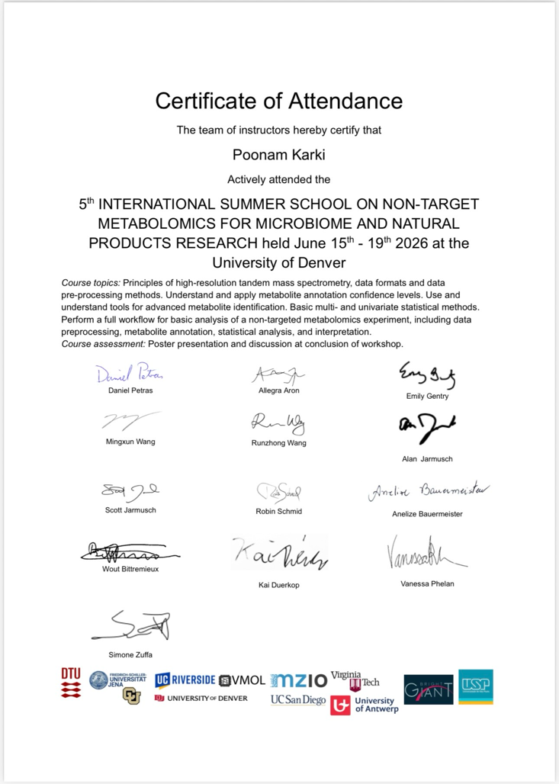
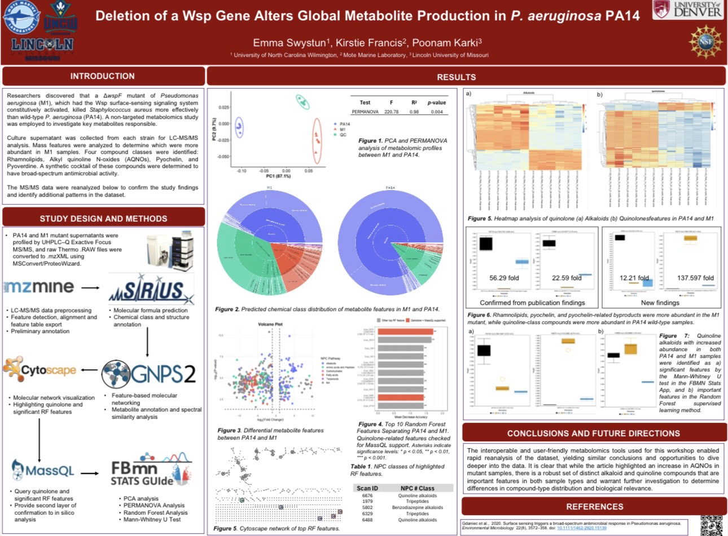
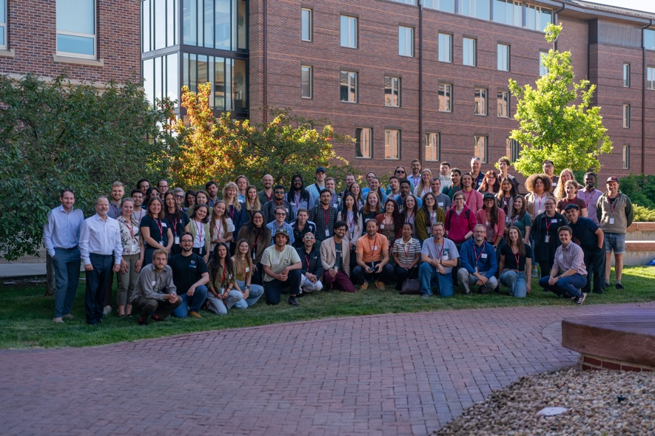
I participated in the 5th International School on Non-target Metabolomics for Natural Products and Microbiome Research, where I received training in non-target metabolomics and its applications in natural products and microbiome research. During the program, I also contributed to a poster titled “Deletion of Wsp Gene Global Metabolite Production in Pseudomonas aeruginosa PA14,” expanding my exposure to metabolomics-based approaches for investigating microbial systems.

1890 ARD Research Symposium
New Orleans, Louisiana | 2026
At the 2026 1890 ARD Research Symposium, I presented my research on soil health comparisons between annual and perennial cover crops established in alleyways between vegetable production beds during organic transition. The symposium provided an opportunity to communicate findings from our organic vegetable production research and engage with scientists working across agriculture, natural resources, and related disciplines.
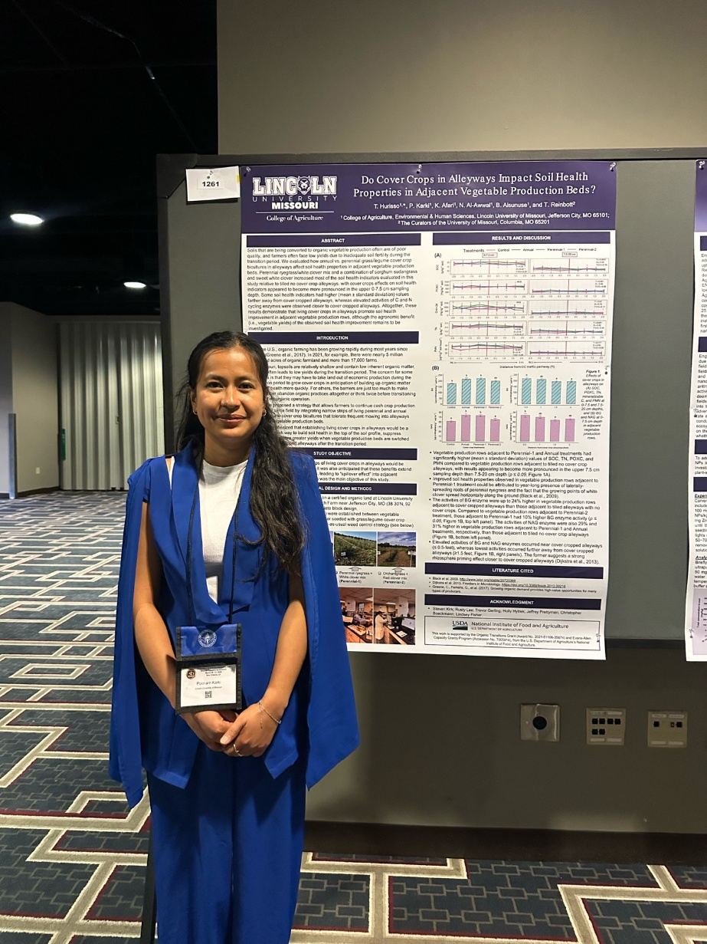
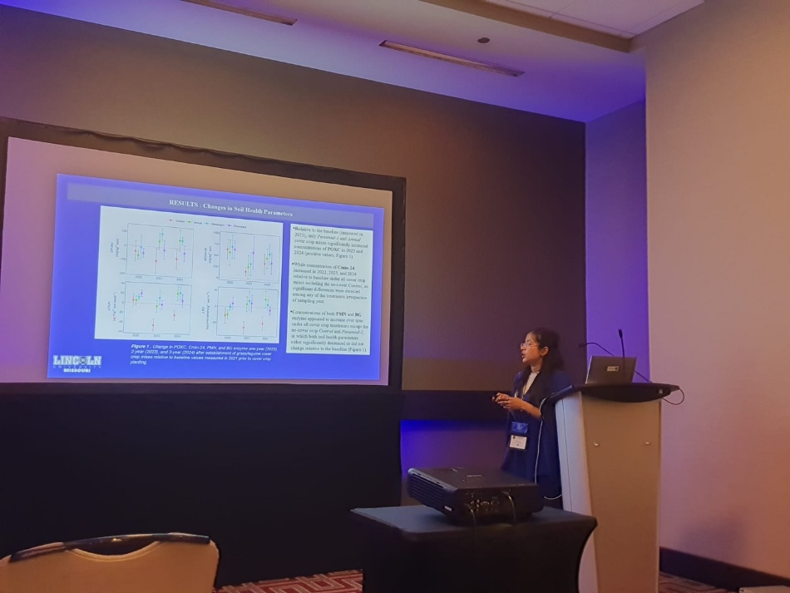

Marbleseed Organic Farming Conference
La Crosse, Wisconsin | 2026
I participated in the 2026 Marbleseed Organic Farming Conference, which brought together farmers, researchers, educators, and agricultural professionals interested in organic and sustainable production systems. The conference provided valuable opportunities to engage with farmer-centered discussions on organic agriculture, soil management, and sustainable farming practices.
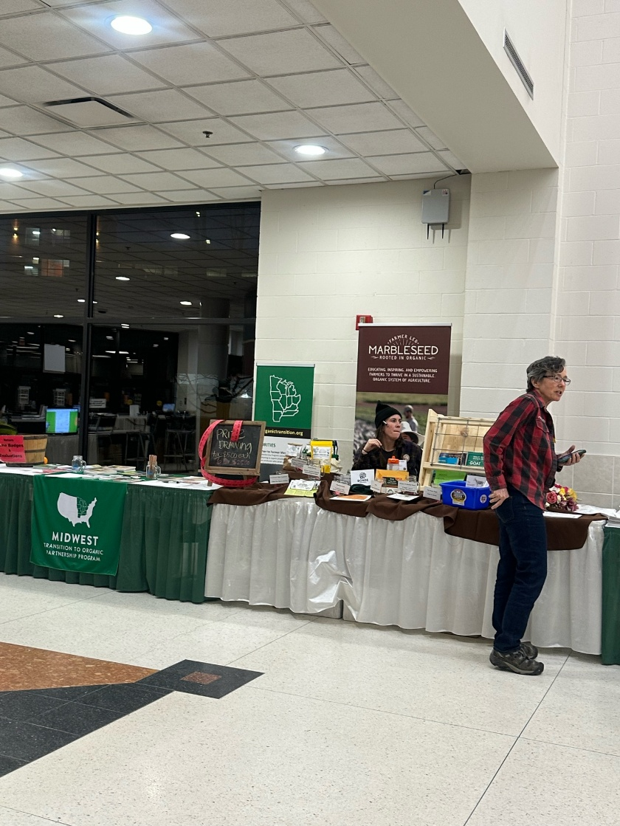
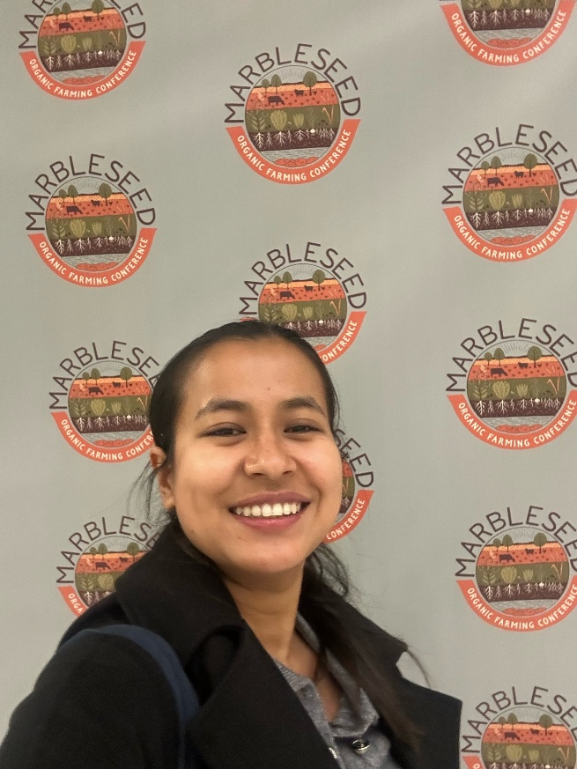

Great Plains Growers Conference
St. Joseph, Missouri | 2026
At the 2026 Great Plains Growers Conference, I presented research titled “Perennial versus Annual Cover Crops in Alleyways: Impacts on Soil Health and Weed Suppression in Organic Vegetable Production.” The presentation highlighted how different alleyway cover-cropping strategies influence soil health and weed management during transition to organic vegetable production.
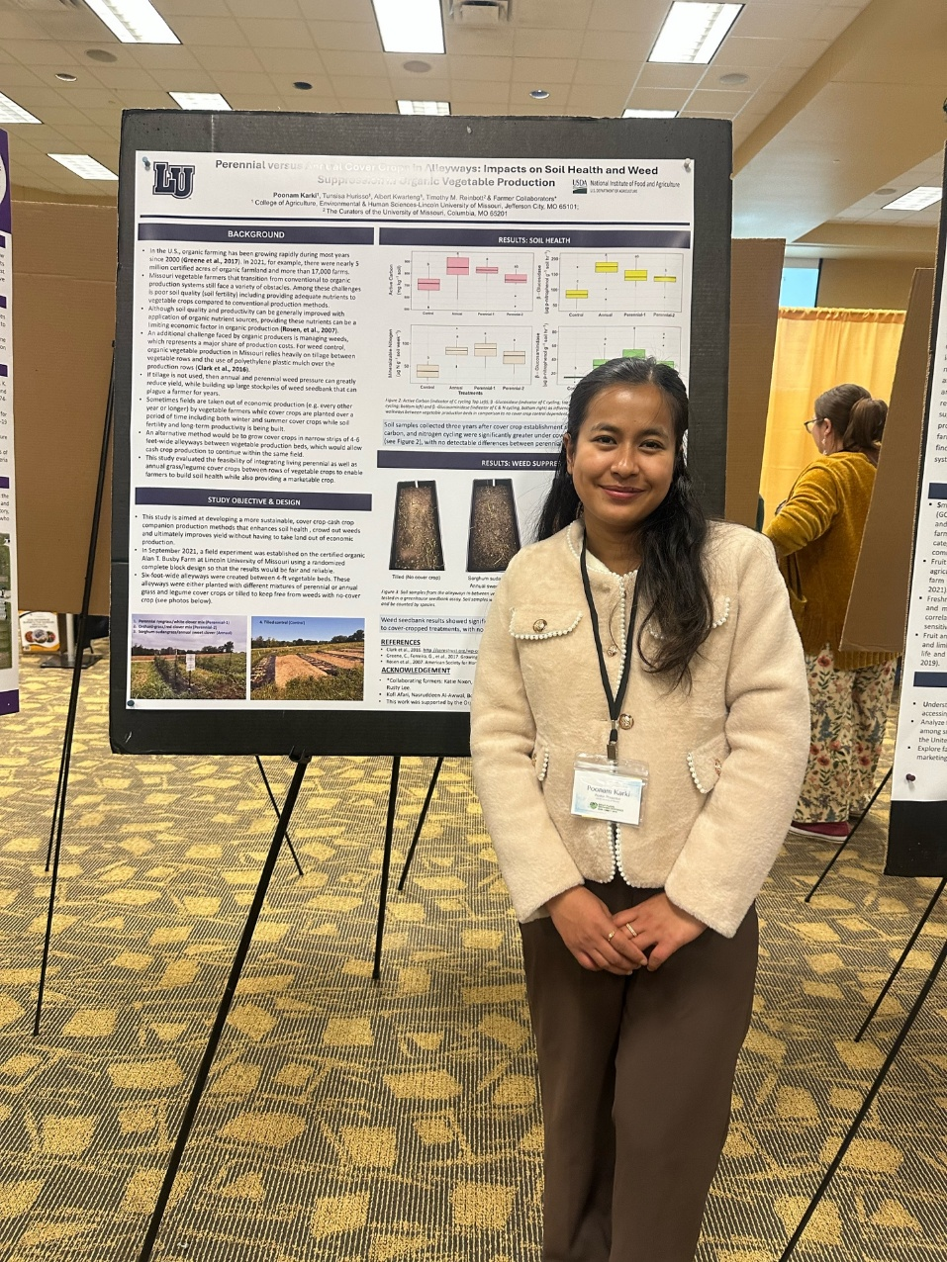
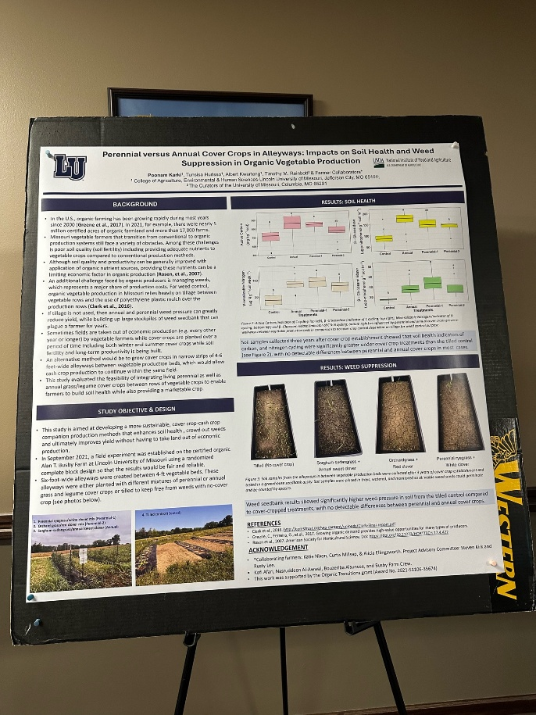

Soil Health Institute's 10th Anniversary Virtual Meeting
Virtual | 2025
I presented my research on soil health comparisons between annual and perennial cover crops in alleyways between vegetable production beds during organic transition at the Soil Health Institute's 10th Anniversary Virtual Meeting. The meeting provided an opportunity to share our findings with the broader soil-health community and connect our research with ongoing efforts to advance practical and scientifically based soil-health assessment.
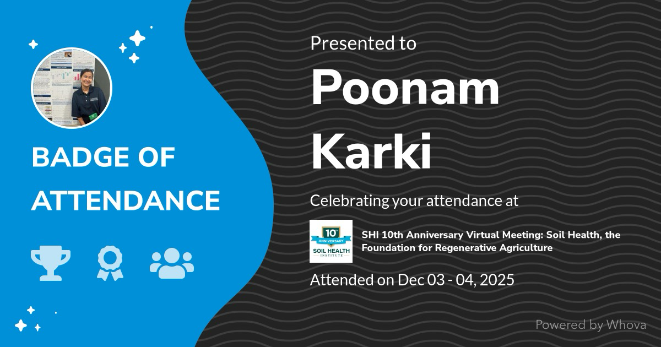

ASA, CSSA & SSSA International Annual Meeting
Salt Lake City, Utah | 2025
At the 2025 ASA, CSSA, and SSSA International Annual Meeting, I presented research examining the effects of living cover crops in alleyways on soil health properties of adjacent organic vegetable production rows. This work expanded our investigation beyond the alleyways themselves to determine whether cover-crop management could influence soil conditions within neighboring vegetable production beds.
